Full_adder

behavioral simulation
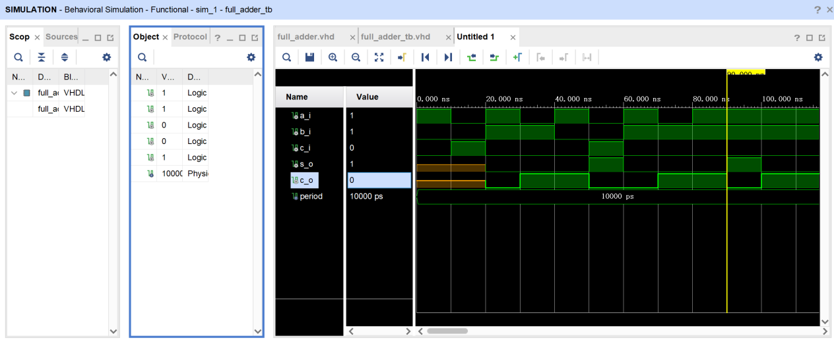

Post-synthesis simulation - functional
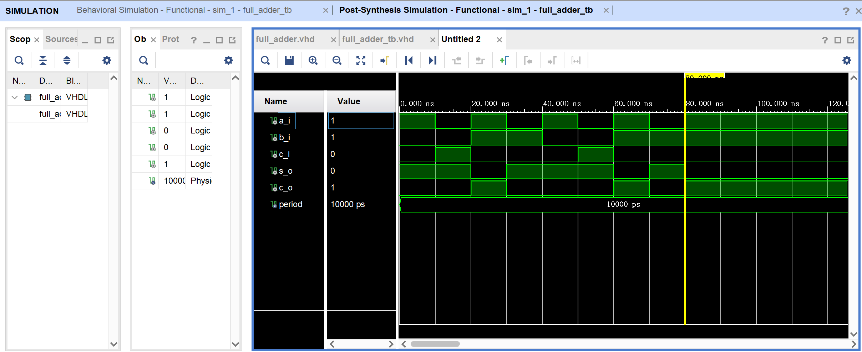

Post-synthesis simulation - timing
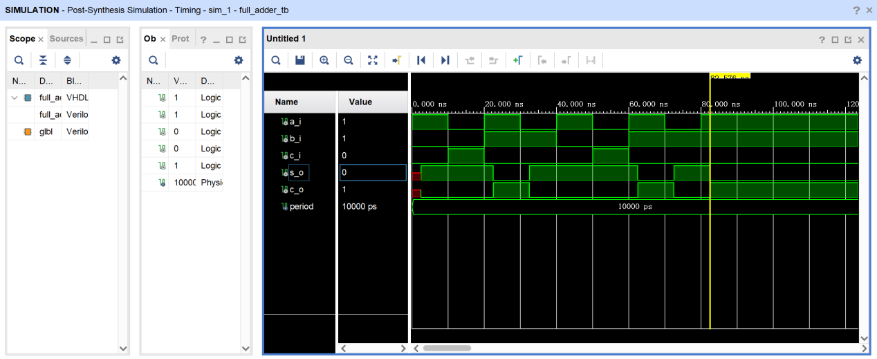

Post-implementation simulation - functional
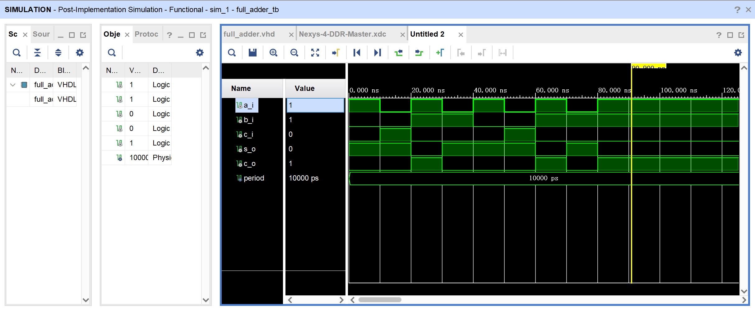

Post-implementation simulation - timing
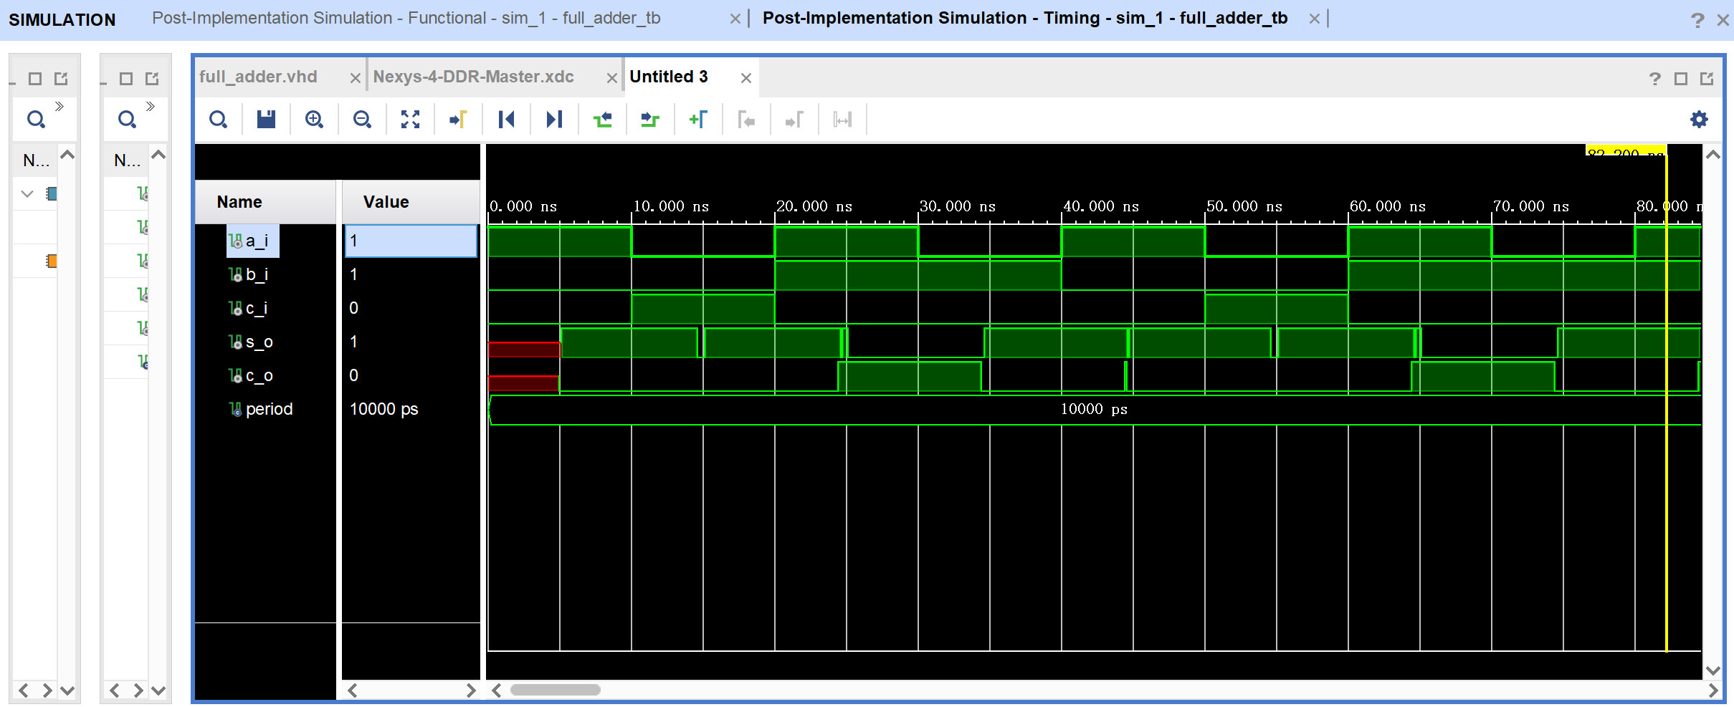

Sig_var
Behavioral simulation
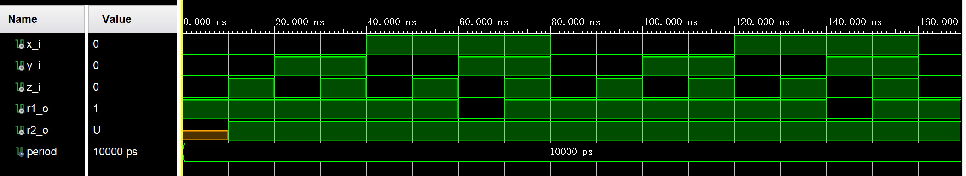

Post-synthesis simulation - functional
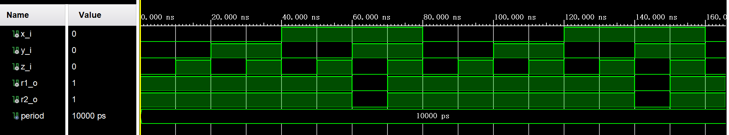

Post-synthesis simulation - timing
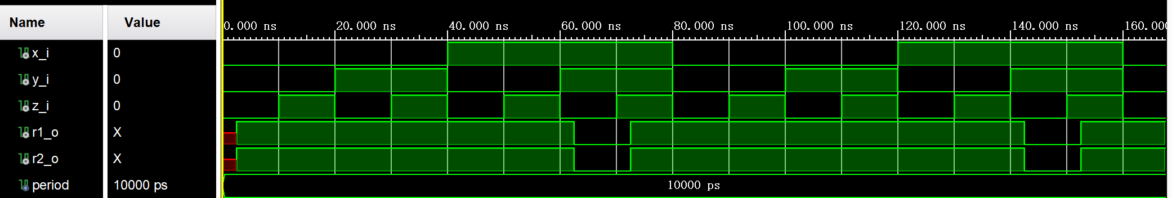

Post-implementation simulation - functional
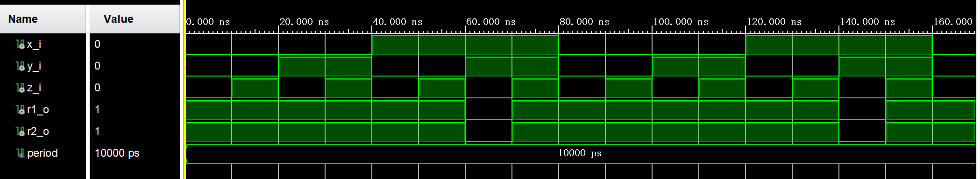

Post-implementation simulation - timing
